UNIVERSIDAD AUTONOMA DEL ESTADO DE MEXICO

FACULTAD DE CIENCIAS

LICENCIATURA EN BIOTECNOLOGIA

BIOINFORMATICA AVANZADA

PROF. ARMANDO SUNNY

ALUMNA. CARINA HINOJOSA GONZALEZ

> mtcars

mpg cyl disp hp drat wt qsec vs am gear carb

Mazda RX4 21.0 6 160.0 110 3.90 2.620 16.46 0 1 4 4

Mazda RX4 Wag 21.0 6 160.0 110 3.90 2.875 17.02 0 1 4 4

Datsun 710 22.8 4 108.0 93 3.85 2.320 18.61 1 1 4 1

Hornet 4 Drive 21.4 6 258.0 110 3.08 3.215 19.44 1 0 3 1

Hornet Sportabout 18.7 8 360.0 175 3.15 3.440 17.02 0 0 3 2

Valiant 18.1 6 225.0 105 2.76 3.460 20.22 1 0 3 1

Duster 360 14.3 8 360.0 245 3.21 3.570 15.84 0 0 3 4

Merc 240D 24.4 4 146.7 62 3.69 3.190 20.00 1 0 4 2

Merc 230 22.8 4 140.8 95 3.92 3.150 22.90 1 0 4 2

Merc 280 19.2 6 167.6 123 3.92 3.440 18.30 1 0 4 4

Merc 280C 17.8 6 167.6 123 3.92 3.440 18.90 1 0 4 4

Merc 450SE 16.4 8 275.8 180 3.07 4.070 17.40 0 0 3 3

Merc 450SL 17.3 8 275.8 180 3.07 3.730 17.60 0 0 3 3

Merc 450SLC 15.2 8 275.8 180 3.07 3.780 18.00 0 0 3 3

Cadillac Fleetwood 10.4 8 472.0 205 2.93 5.250 17.98 0 0 3 4

Lincoln Continental 10.4 8 460.0 215 3.00 5.424 17.82 0 0 3 4

Chrysler Imperial 14.7 8 440.0 230 3.23 5.345 17.42 0 0 3 4

Fiat 128 32.4 4 78.7 66 4.08 2.200 19.47 1 1 4 1

Honda Civic 30.4 4 75.7 52 4.93 1.615 18.52 1 1 4 2

Toyota Corolla 33.9 4 71.1 65 4.22 1.835 19.90 1 1 4 1

Toyota Corona 21.5 4 120.1 97 3.70 2.465 20.01 1 0 3 1

Dodge Challenger 15.5 8 318.0 150 2.76 3.520 16.87 0 0 3 2

AMC Javelin 15.2 8 304.0 150 3.15 3.435 17.30 0 0 3 2

Camaro Z28 13.3 8 350.0 245 3.73 3.840 15.41 0 0 3 4

Pontiac Firebird 19.2 8 400.0 175 3.08 3.845 17.05 0 0 3 2

Fiat X1-9 27.3 4 79.0 66 4.08 1.935 18.90 1 1 4 1

Porsche 914-2 26.0 4 120.3 91 4.43 2.140 16.70 0 1 5 2

Lotus Europa 30.4 4 95.1 113 3.77 1.513 16.90 1 1 5 2

Ford Pantera L 15.8 8 351.0 264 4.22 3.170 14.50 0 1 5 4

Ferrari Dino 19.7 6 145.0 175 3.62 2.770 15.50 0 1 5 6

Maserati Bora 15.0 8 301.0 335 3.54 3.570 14.60 0 1 5 8

Volvo 142E 21.4 4 121.0 109 4.11 2.780 18.60 1 1 4 2

> data <- as.matrix(mtcars)

> heatmap(data)

> heatmap(data, Colv = NA, Rowv = NA, scale="column")

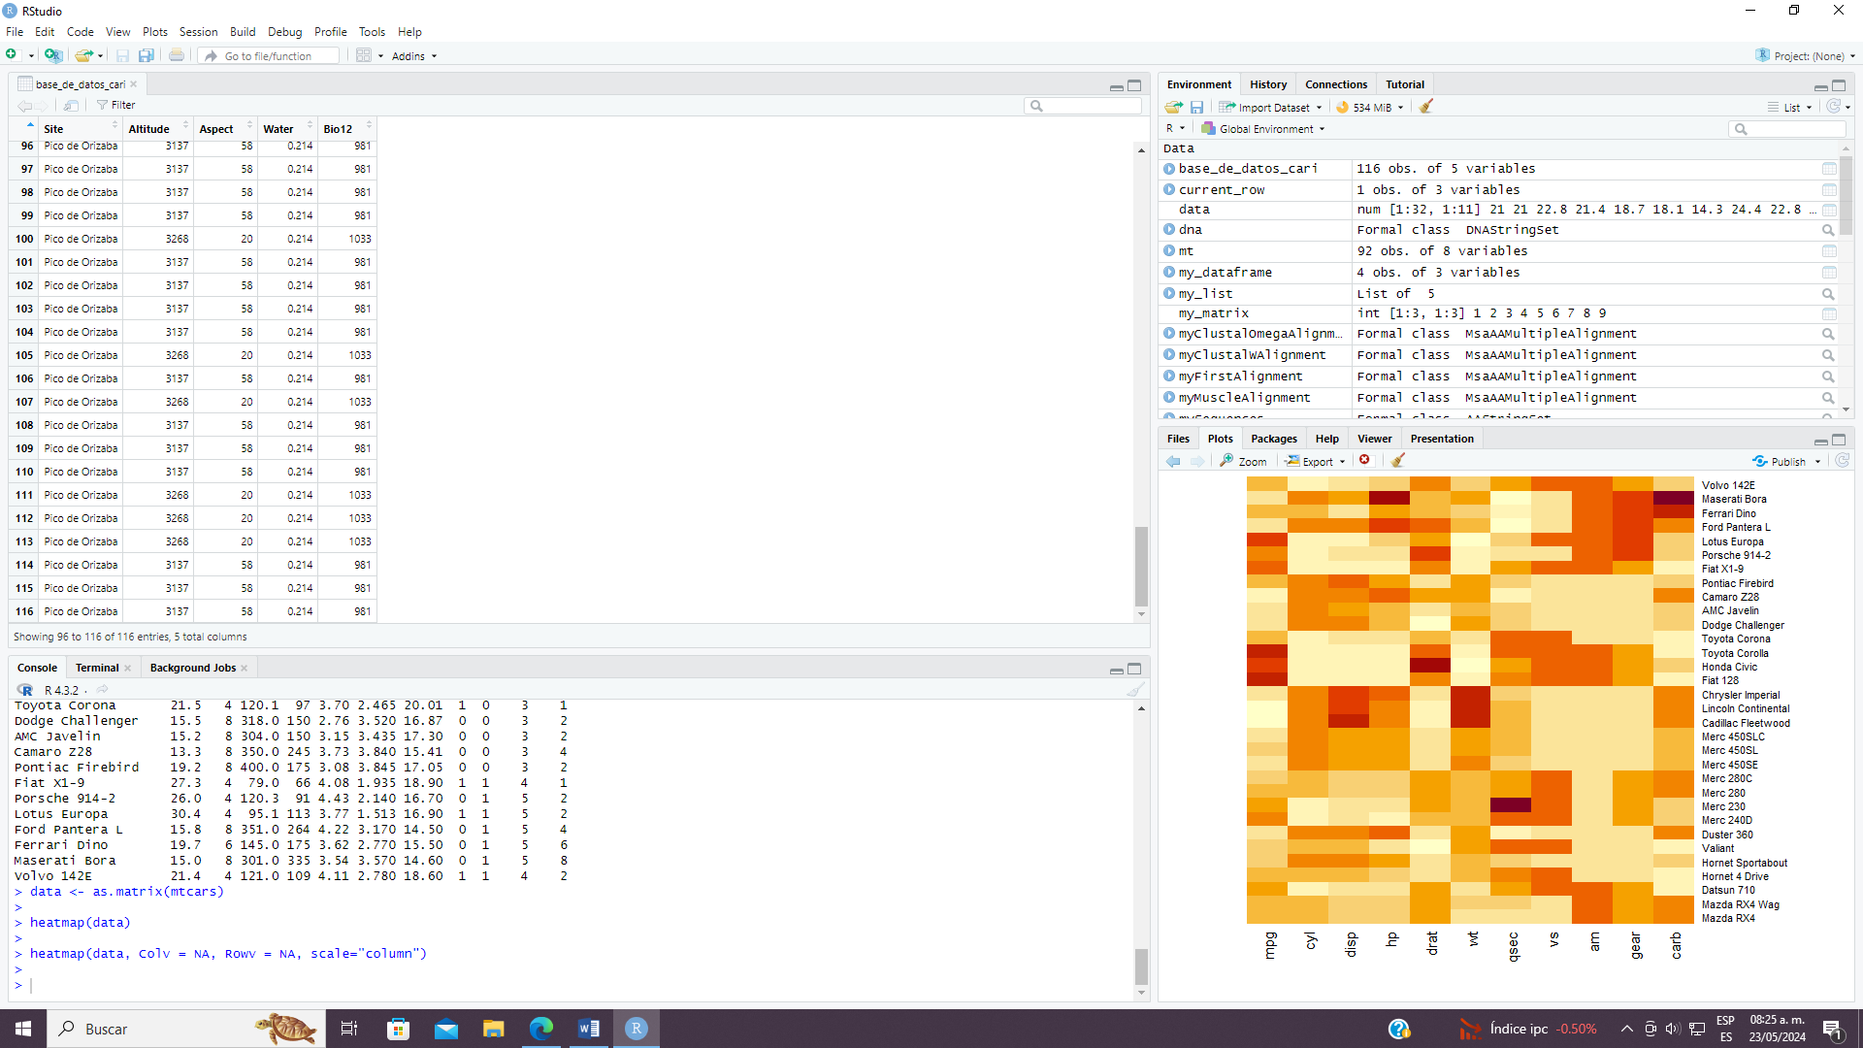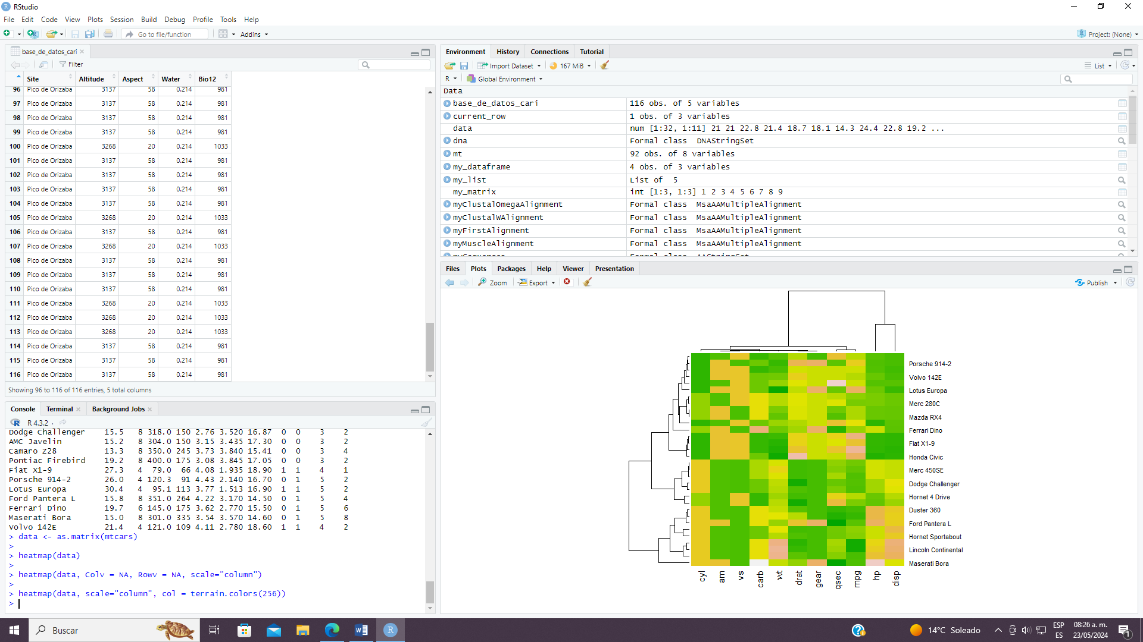

EJERCICIO 2

> install.packages("corrplot")

> library(corrplot)

> data ("mtcars")

> head(mtcars)

mpg cyl disp hp drat wt qsec vs am gear carb

Mazda RX4 21.0 6 160 110 3.90 2.620 16.46 0 1 4 4

Mazda RX4 Wag 21.0 6 160 110 3.90 2.875 17.02 0 1 4 4

Datsun 710 22.8 4 108 93 3.85 2.320 18.61 1 1 4 1

Hornet 4 Drive 21.4 6 258 110 3.08 3.215 19.44 1 0 3 1

Hornet Sportabout 18.7 8 360 175 3.15 3.440 17.02 0 0 3 2

Valiant 18.1 6 225 105 2.76 3.460 20.22 1 0 3 1

> c<-cor(mtcars)

> corrplot(c,method="number")

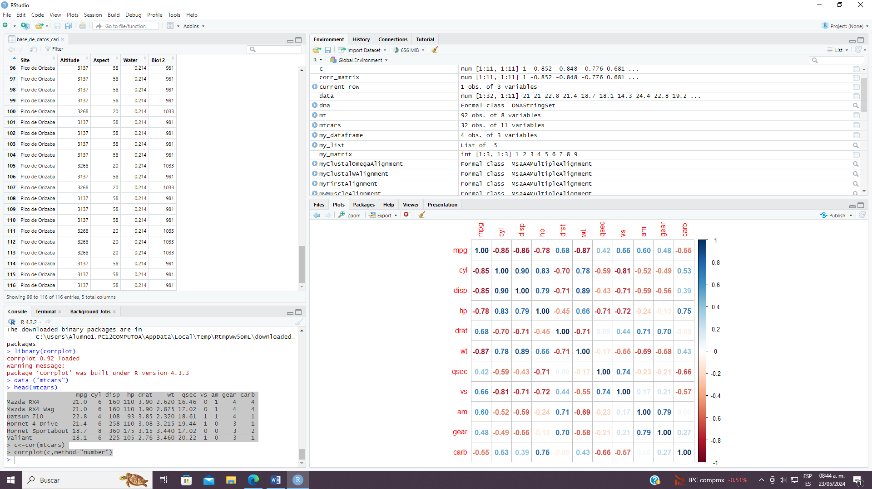

> any(is.na(mtcars))

[1] FALSE

> str(mtcars)

'data.frame': 32 obs. of 11 variables:

$ mpg : num 21 21 22.8 21.4 18.7 18.1 14.3 24.4 22.8 19.2 ...

$ cyl : num 6 6 4 6 8 6 8 4 4 6 ...

$ disp: num 160 160 108 258 360 ...

$ hp : num 110 110 93 110 175 105 245 62 95 123 ...

$ drat: num 3.9 3.9 3.85 3.08 3.15 2.76 3.21 3.69 3.92 3.92 ...

$ wt : num 2.62 2.88 2.32 3.21 3.44 ...

$ qsec: num 16.5 17 18.6 19.4 17 ...

$ vs : num 0 0 1 1 0 1 0 1 1 1 ...

$ am : num 1 1 1 0 0 0 0 0 0 0 ...

$ gear: num 4 4 4 3 3 3 3 4 4 4 ...

$ carb: num 4 4 1 1 2 1 4 2 2 4 ...

> str(mtcars)

'data.frame': 32 obs. of 11 variables:

$ mpg : num 21 21 22.8 21.4 18.7 18.1 14.3 24.4 22.8 19.2 ...

$ cyl : num 6 6 4 6 8 6 8 4 4 6 ...

$ disp: num 160 160 108 258 360 ...

$ hp : num 110 110 93 110 175 105 245 62 95 123 ...

$ drat: num 3.9 3.9 3.85 3.08 3.15 2.76 3.21 3.69 3.92 3.92 ...

$ wt : num 2.62 2.88 2.32 3.21 3.44 ...

$ qsec: num 16.5 17 18.6 19.4 17 ...

$ vs : num 0 0 1 1 0 1 0 1 1 1 ...

$ am : num 1 1 1 0 0 0 0 0 0 0 ...

$ gear: num 4 4 4 3 3 3 3 4 4 4 ...

$ carb: num 4 4 1 1 2 1 4 2 2 4 ...

> symmary(mtcars)

Error in symmary(mtcars) : no se pudo encontrar la función "symmary"

> summary(mtcars)

mpg cyl disp

Min. :10.40 Min. :4.000 Min. : 71.1

1st Qu.:15.43 1st Qu.:4.000 1st Qu.:120.8

Median :19.20 Median :6.000 Median :196.3

Mean :20.09 Mean :6.188 Mean :230.7

3rd Qu.:22.80 3rd Qu.:8.000 3rd Qu.:326.0

Max. :33.90 Max. :8.000 Max. :472.0

hp drat wt

Min. : 52.0 Min. :2.760 Min. :1.513

1st Qu.: 96.5 1st Qu.:3.080 1st Qu.:2.581

Median :123.0 Median :3.695 Median :3.325

Mean :146.7 Mean :3.597 Mean :3.217

3rd Qu.:180.0 3rd Qu.:3.920 3rd Qu.:3.610

Max. :335.0 Max. :4.930 Max. :5.424

qsec vs am

Min. :14.50 Min. :0.0000 Min. :0.0000

1st Qu.:16.89 1st Qu.:0.0000 1st Qu.:0.0000

Median :17.71 Median :0.0000 Median :0.0000

Mean :17.85 Mean :0.4375 Mean :0.4062

3rd Qu.:18.90 3rd Qu.:1.0000 3rd Qu.:1.0000

Max. :22.90 Max. :1.0000 Max. :1.0000

gear carb

Min. :3.000 Min. :1.000

1st Qu.:3.000 1st Qu.:2.000

Median :4.000 Median :2.000

Mean :3.688 Mean :2.812

3rd Qu.:4.000 3rd Qu.:4.000

Max. :5.000 Max. :8.000

> anova_model<-aov(mpg~cyl, data = mtcars)

> summary(anova_model)

Df Sum Sq Mean Sq F value Pr(>F)

cyl 1 817.7 817.7 79.56 6.11e-10 ***

Residuals 30 308.3 10.3

---

Signif. codes:

0 ‘***’ 0.001 ‘**’ 0.01 ‘*’ 0.05 ‘.’ 0.1 ‘ ’ 1

> boxplot(mpg~cyl,data=mtcars,

+ col=c("lightpink","lightyellow","lightblue"),

+ main="ANOVA Boxplot")

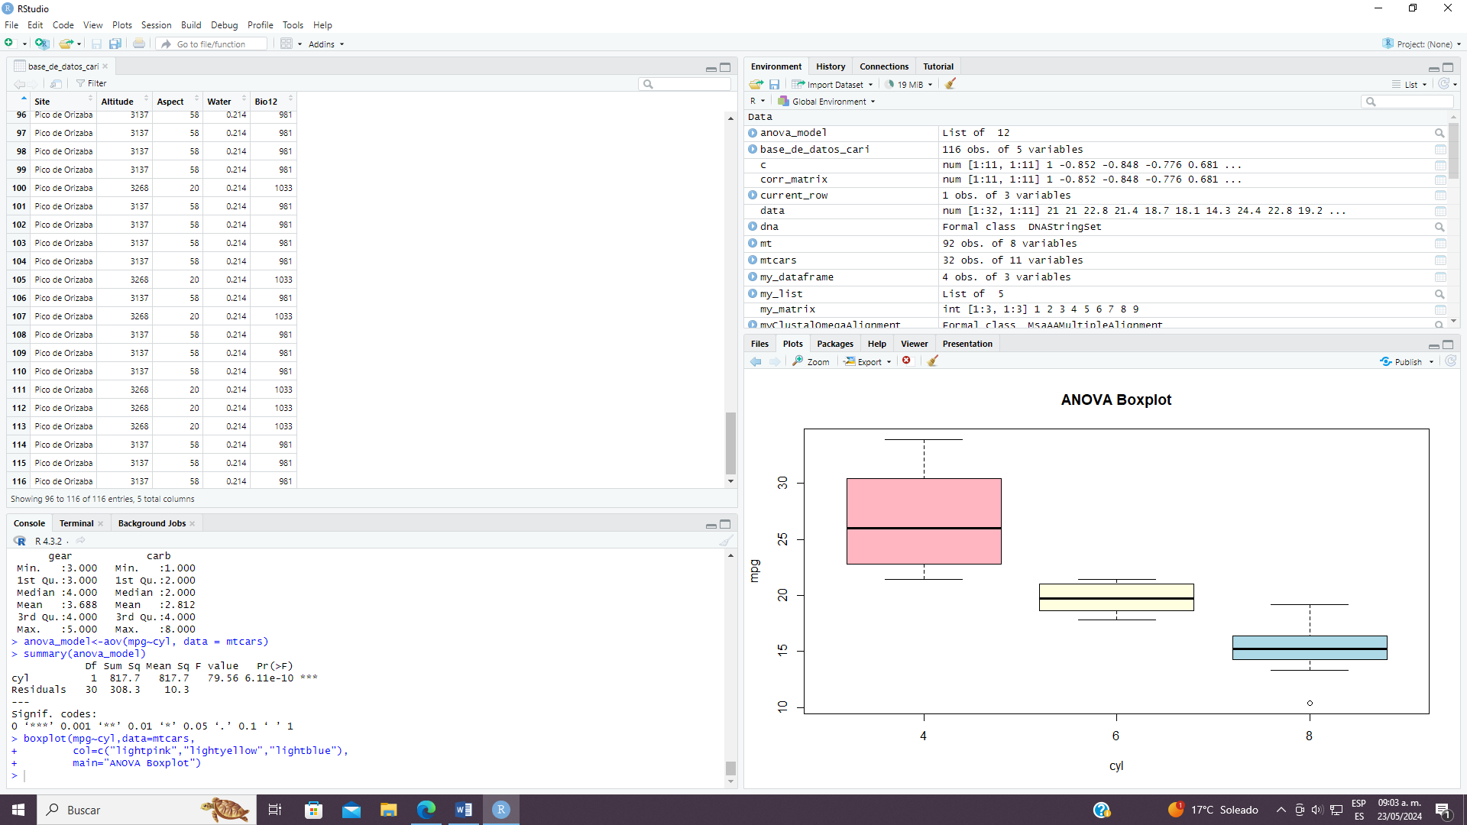

(library("tidyverse"))

[1] "corrplot" "lubridate" "forcats" "stringr" "dplyr" "purrr" "readr"

[8] "tidyr" "tibble" "ggplot2" "tidyverse" "msa" "Biostrings" "GenomeInfoDb"

[15] "XVector" "IRanges" "S4Vectors" "stats4" "BiocGenerics" "stats" "graphics"

[22] "grDevices" "utils" "datasets" "methods" "base"

> (library("stringr"))

[1] "corrplot" "lubridate" "forcats" "stringr" "dplyr" "purrr" "readr"

[8] "tidyr" "tibble" "ggplot2" "tidyverse" "msa" "Biostrings" "GenomeInfoDb"

[15] "XVector" "IRanges" "S4Vectors" "stats4" "BiocGenerics" "stats" "graphics"

[22] "grDevices" "utils" "datasets" "methods" "base"

> output <- vector("double", ncol(mtcars))

> names(output) <- names(mtcars)

> for (i in names(mtcars)) {

+ output[i] <- mean(mtcars[[i]])

+ }

> output

mpg cyl disp hp drat wt qsec vs am gear

20.090625 6.187500 230.721875 146.687500 3.596563 3.217250 17.848750 0.437500 0.406250 3.687500

carb

2.812500

> output <- vector("list", ncol(nycflights13::flights))

Error in (function (cond) :

error in evaluating the argument 'x' in selecting a method for function 'ncol': there is no package called ‘nycflights13’

> output <- vector("list", ncol(nycflights13::flights))

Error in (function (cond) :

error in evaluating the argument 'x' in selecting a method for function 'ncol': there is no package called ‘nycflights13’

> install.packages(nycflights13)

Error in install.packages : objeto 'nycflights13' no encontrado

> install.packages("nycflights13")

probando la URL 'https://cran.rstudio.com/bin/windows/contrib/4.3/nycflights13_1.0.2.zip'

Content type 'application/zip' length 4510470 bytes (4.3 MB)

downloaded 4.3 MB

package ‘nycflights13’ successfully unpacked and MD5 sums checked

The downloaded binary packages are in

C:\Users\Alumno1.PC12COMPUTOA\AppData\Local\Temp\RtmpWw5omL\downloaded_packages

> output <- vector("list", ncol(nycflights13::flights))

>

> names(output) <- names(nycflights13::flights)

> for (i in names(nycflights13::flights)) {

+ output[[i]] <- class(nycflights13::flights[[i]])

+ }

> output

$year

[1] "integer"

$month

[1] "integer"

$day

[1] "integer"

$dep_time

[1] "integer"

$sched_dep_time

[1] "integer"

$dep_delay

[1] "numeric"

$arr_time

[1] "integer"

$sched_arr_time

[1] "integer"

$arr_delay

[1] "numeric"

$carrier

[1] "character"

$flight

[1] "integer"

$tailnum

[1] "character"

$origin

[1] "character"

$dest

[1] "character"

$air_time

[1] "numeric"

$distance

[1] "numeric"

$hour

[1] "numeric"

$minute

[1] "numeric"

$time_hour

[1] "POSIXct" "POSIXt"

> data("iris")

> iris_uniq <- vector("double", ncol(iris))

> names(iris_uniq) <- names(iris)

> for (i in names(iris)) {

+ iris_uniq[i] <- length(unique(iris[[i]]))

+ }

> iris_uniq

Sepal.Length Sepal.Width Petal.Length Petal.Width Species

35 23 43 22 3

>

> n <- 10

> # values of the mean

> mu <- c(-10, 0, 10, 100)

> normals <- vector("list", length(mu))

> for (i in seq_along(normals)) {

+ normals[[i]] <- rnorm(n, mean = mu[i])

+ }

> normals

[[1]]

[1] -10.826366 -10.990863 -10.278715 -9.045622 -9.914845 -9.916772 -9.872186 -10.414968 -8.984597

[10] -9.736405

[[2]]

[1] -0.00186675 0.47935154 1.09266573 1.01678335 -0.41600937 1.52718682 1.27835777 -1.55014491 0.92492261

[10] 0.96131191

[[3]]

[1] 8.687705 10.649232 8.700926 8.939139 9.689645 9.980005 9.441360 10.266999 8.986128 11.332860

[[4]]

[1] 100.58392 100.43640 99.60954 99.69960 99.27784 101.26677 99.50478 100.20550 100.95883 100.09959

> matrix(rnorm(n * length(mu), mean = mu), ncol = n)

[,1] [,2] [,3] [,4] [,5] [,6] [,7] [,8] [,9]

[1,] -9.6293553 -7.431248 -9.4449863 -9.454240 -10.8202073 -10.2503827 -10.3365837 -10.216655 -9.827654

[2,] 0.1877544 -1.280977 0.3988413 1.177973 -0.4214706 -0.7744623 -0.9852422 -1.677233 -1.000194

[3,] 9.6600700 10.510931 11.3780735 10.559495 9.9292345 12.3521922 12.0389672 11.104737 8.762058

[4,] 100.3837576 100.114556 100.8162985 101.032002 100.5336672 99.9356019 99.3926393 101.123894 99.320401

[,10]

[1,] -9.9573699

[2,] -0.7738948

[3,] 9.9432735

[4,] 99.1953215

> out <- ""

> for (x in letters) {

+ out <- str_c(out, x)

+ }

> out

[1] "abcdefghijklmnopqrstuvwxyz"

> str_c(letters, collapse = "")

[1] "abcdefghijklmnopqrstuvwxyz"

> x <- sample(100)

> sd. <- 0

> for (i in seq_along(x)) {

+ sd. <- sd. + (x[i] - mean(x))^2

+ }

> sd. <- sqrt(sd. / (length(x) - 1))

> sd.

[1] 29.01149

> sd(x)

[1] 29.01149

> sqrt(sum((x - mean(x))^2) / (length(x) - 1))

[1] 29.01149

> x <- runif(100)

> out <- vector("numeric", length(x))

> out[1] <- x[1]

> for (i in 2:length(x)) {

+ out[i] <- out[i - 1] + x[i]

+ }

> out

[1] 0.1356253 0.9154960 1.1409454 1.1703463 1.1843833 1.9930598 2.8468568 3.0213893 4.0033992

[10] 4.5689064 5.4433400 5.8070458 6.3963409 6.8446237 7.5409310 7.8198911 8.3929249 9.0441493

[19] 9.1302147 9.4235008 9.9750655 10.4139451 10.4496657 10.9844507 11.8018242 12.1884683 12.4913228

[28] 12.7965141 13.5358075 13.8991291 14.7876998 14.9065307 15.6655312 15.7390102 16.0132199 16.1976243

[37] 16.8314524 17.5678097 18.0056007 18.3703256 19.1796062 19.9944799 20.5440925 21.4324213 22.2636737

[46] 22.6618106 23.4087932 23.7400649 24.6207415 25.2590804 25.9049409 26.1679373 26.3731250 26.5883270

[55] 27.1360010 27.9023065 28.4148523 29.3509634 30.1542130 30.5071164 30.7525020 31.5252732 32.2011035

[64] 33.1380861 33.2508983 33.4831419 33.8522637 34.0883366 34.5026798 35.3597602 35.9871311 36.0864600

[73] 36.4532054 36.7151963 37.2411797 38.1200360 38.6225073 38.6571440 38.7318493 38.7635342 38.8149185

[82] 39.3919740 40.0940004 40.8613529 41.1328725 41.2630887 41.9156264 42.5160804 42.7703521 43.1855939

[91] 43.8110042 44.2272195 44.4804996 44.7810075 44.8228298 45.3884619 46.0668289 46.3200726 46.5260160

[100] 47.2758001

> all.equal(cumsum(x), out)

[1] TRUE

> humps <- c("five", "four", "three", "two", "one", "no")

> for (i in humps) {

+ cat(str_c("Alice the camel has ", rep(i, 3), " humps.",

+ collapse = "\n"

+ ), "\n")

+ if (i == "no") {

+ cat("Now Alice is a horse.\n")

+ } else {

+ cat("So go, Alice, go.\n")

+ }

+ cat("\n")

+ }

Alice the camel has five humps.

Alice the camel has five humps.

Alice the camel has five humps.

So go, Alice, go.

Alice the camel has four humps.

Alice the camel has four humps.

Alice the camel has four humps.

So go, Alice, go.

Alice the camel has three humps.

Alice the camel has three humps.

Alice the camel has three humps.

So go, Alice, go.

Alice the camel has two humps.

Alice the camel has two humps.

Alice the camel has two humps.

So go, Alice, go.

Alice the camel has one humps.

Alice the camel has one humps.

Alice the camel has one humps.

So go, Alice, go.

Alice the camel has no humps.

Alice the camel has no humps.

Alice the camel has no humps.

Now Alice is a horse.

> numbers <- c(

+ "ten", "nine", "eight", "seven", "six", "five",

+ "four", "three", "two", "one"

+ )

> for (i in numbers) {

+ cat(str_c("There were ", i, " in the bed\n"))

+ cat("and the little one said\n")

+ if (i == "one") {

+ cat("I'm lonely...")

+ } else {

+ cat("Roll over, roll over\n")

+ cat("So they all rolled over and one fell out.\n")

+ }

+ cat("\n")

+ }

There were ten in the bed

and the little one said

Roll over, roll over

So they all rolled over and one fell out.

There were nine in the bed

and the little one said

Roll over, roll over

So they all rolled over and one fell out.

There were eight in the bed

and the little one said

Roll over, roll over

So they all rolled over and one fell out.

There were seven in the bed

and the little one said

Roll over, roll over

So they all rolled over and one fell out.

There were six in the bed

and the little one said

Roll over, roll over

So they all rolled over and one fell out.

There were five in the bed

and the little one said

Roll over, roll over

So they all rolled over and one fell out.

There were four in the bed

and the little one said

Roll over, roll over

So they all rolled over and one fell out.

There were three in the bed

and the little one said

Roll over, roll over

So they all rolled over and one fell out.

There were two in the bed

and the little one said

Roll over, roll over

So they all rolled over and one fell out.

There were one in the bed

and the little one said

I'm lonely...

> bottles <- function(n) {

+ if (n > 1) {

+ str_c(n, " bottles")

+ } else if (n == 1) {

+ "1 bottle"

+ } else {

+ "no more bottles"

+ }

+ }

>

> beer_bottles <- function(total_bottles) {

+ # print each lyric

+ for (current_bottles in seq(total_bottles, 0)) {

+ # first line

+ cat(str_to_sentence(str_c(bottles(current_bottles), " of beer on the wall, ", bottles(current_bottles), " of beer.\n")))

+ # second line

+ if (current_bottles > 0) {

+ cat(str_c(

+ "Take one down and pass it around, ", bottles(current_bottles - 1),

+ " of beer on the wall.\n"

+ ))

+ } else {

+ cat(str_c("Go to the store and buy some more, ", bottles(total_bottles), " of beer on the wall.\n"))

+ }

+ cat("\n")

+ }

+ }

> beer_bottles(3)

3 bottles of beer on the wall, 3 bottles of beer.

Take one down and pass it around, 2 bottles of beer on the wall.

2 bottles of beer on the wall, 2 bottles of beer.

Take one down and pass it around, 1 bottle of beer on the wall.

1 bottle of beer on the wall, 1 bottle of beer.

Take one down and pass it around, no more bottles of beer on the wall.

No more bottles of beer on the wall, no more bottles of beer.

Go to the store and buy some more, 3 bottles of beer on the wall.

> output <- vector("integer", 0)

> for (i in seq_along(x)) {

+ output <- c(output, lengths(x[[i]]))

+ }

> output

[1] 1 1 1 1 1 1 1 1 1 1 1 1 1 1 1 1 1 1 1 1 1 1 1 1 1 1 1 1 1 1 1 1 1 1 1 1 1 1 1 1 1 1 1 1 1 1 1 1 1 1 1 1 1

[54] 1 1 1 1 1 1 1 1 1 1 1 1 1 1 1 1 1 1 1 1 1 1 1 1 1 1 1 1 1 1 1 1 1 1 1 1 1 1 1 1 1 1 1 1 1 1 1

> add_to_vector <- function(n) {

+ output <- vector("integer", 0)

+ for (i in seq_len(n)) {

+ output <- c(output, i)

+ }

+ output

+ }

> add_to_vector_2 <- function(n) {

+ output <- vector("integer", n)

+ for (i in seq_len(n)) {

+ output[[i]] <- i

+ }

+ output

+ }

> timings <- microbenchmark(add_to_vector(10000), add_to_vector_2(10000), times = 10)

Error in microbenchmark(add_to_vector(10000), add_to_vector_2(10000), :

no se pudo encontrar la función "microbenchmark"

> (library("microbenchmark"))

Error in library("microbenchmark") :

there is no package called ‘microbenchmark’

> install.packages(microbenchmark)

Error in install.packages : objeto 'microbenchmark' no encontrado

> install.packages("microbenchmark")

probando la URL 'https://cran.rstudio.com/bin/windows/contrib/4.3/microbenchmark_1.4.10.zip'

Content type 'application/zip' length 68300 bytes (66 KB)

downloaded 66 KB

package ‘microbenchmark’ successfully unpacked and MD5 sums checked

The downloaded binary packages are in

C:\Users\Alumno1.PC12COMPUTOA\AppData\Local\Temp\RtmpWw5omL\downloaded_packages

> (library("microbenchmark"))

[1] "microbenchmark" "corrplot" "lubridate" "forcats" "stringr" "dplyr"

[7] "purrr" "readr" "tidyr" "tibble" "ggplot2" "tidyverse"

[13] "msa" "Biostrings" "GenomeInfoDb" "XVector" "IRanges" "S4Vectors"

[19] "stats4" "BiocGenerics" "stats" "graphics" "grDevices" "utils"

[25] "datasets" "methods" "base"

Warning message:

package ‘microbenchmark’ was built under R version 4.3.3

> timings <- microbenchmark(add_to_vector(10000), add_to_vector_2(10000), times = 10)

> timings

Unit: microseconds

expr min lq mean median uq max neval cld

add_to_vector(10000) 227037.802 276026.502 312564.641 290008.901 295272.101 608430.901 10 a

add_to_vector_2(10000) 559.701 567.502 1096.971 584.701 594.401 5747.201 10 b

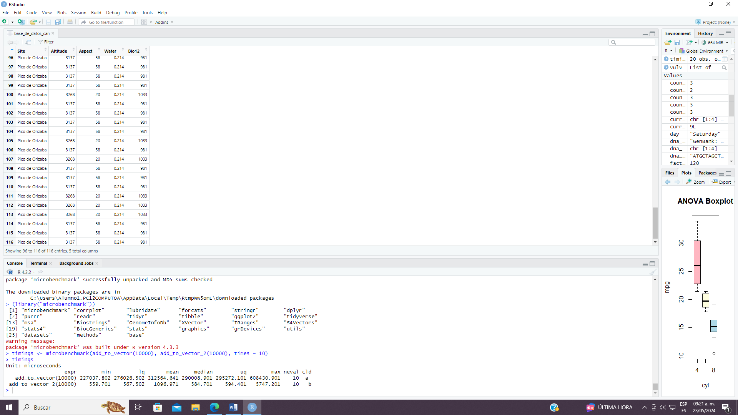

df <- mtcars

> head(df)

mpg cyl disp hp drat wt qsec vs am gear carb

Mazda RX4 21.0 6 160 110 3.90 2.620 16.46 0 1 4 4

Mazda RX4 Wag 21.0 6 160 110 3.90 2.875 17.02 0 1 4 4

Datsun 710 22.8 4 108 93 3.85 2.320 18.61 1 1 4 1

Hornet 4 Drive 21.4 6 258 110 3.08 3.215 19.44 1 0 3 1

Hornet Sportabout 18.7 8 360 175 3.15 3.440 17.02 0 0 3 2

Valiant 18.1 6 225 105 2.76 3.460 20.22 1 0 3 1

> df <- mtcars[,c(1:7,10,11)]

> head(df)

mpg cyl disp hp drat wt qsec gear carb

Mazda RX4 21.0 6 160 110 3.90 2.620 16.46 4 4

Mazda RX4 Wag 21.0 6 160 110 3.90 2.875 17.02 4 4

Datsun 710 22.8 4 108 93 3.85 2.320 18.61 4 1

Hornet 4 Drive 21.4 6 258 110 3.08 3.215 19.44 3 1

Hornet Sportabout 18.7 8 360 175 3.15 3.440 17.02 3 2

Valiant 18.1 6 225 105 2.76 3.460 20.22 3 1

> mtcars.pca <- prcomp(mtcars[,c(1:7,10,11)], center = TRUE, scale. = TRUE)

> summary(mtcars.pca)

Importance of components:

PC1 PC2 PC3 PC4 PC5 PC6 PC7 PC8 PC9

Standard deviation 2.3782 1.4429 0.71008 0.51481 0.42797 0.35184 0.32413 0.2419 0.14896

Proportion of Variance 0.6284 0.2313 0.05602 0.02945 0.02035 0.01375 0.01167 0.0065 0.00247

Cumulative Proportion 0.6284 0.8598 0.91581 0.94525 0.96560 0.97936 0.99103 0.9975 1.00000

> str(mtcars.pca)

List of 5

$ sdev : num [1:9] 2.378 1.443 0.71 0.515 0.428 ...

$ rotation: num [1:9, 1:9] -0.393 0.403 0.397 0.367 -0.312 ...

..- attr(*, "dimnames")=List of 2

.. ..$ : chr [1:9] "mpg" "cyl" "disp" "hp" ...

.. ..$ : chr [1:9] "PC1" "PC2" "PC3" "PC4" ...

$ center : Named num [1:9] 20.09 6.19 230.72 146.69 3.6 ...

..- attr(*, "names")= chr [1:9] "mpg" "cyl" "disp" "hp" ...

$ scale : Named num [1:9] 6.027 1.786 123.939 68.563 0.535 ...

..- attr(*, "names")= chr [1:9] "mpg" "cyl" "disp" "hp" ...

$ x : num [1:32, 1:9] -0.664 -0.637 -2.3 -0.215 1.587 ...

..- attr(*, "dimnames")=List of 2

.. ..$ : chr [1:32] "Mazda RX4" "Mazda RX4 Wag" "Datsun 710" "Hornet 4 Drive" ...

.. ..$ : chr [1:9] "PC1" "PC2" "PC3" "PC4" ...

- attr(*, "class")= chr "prcomp"

> library(devtools)

Loading required package: usethis

Warning message:

package ‘devtools’ was built under R version 4.3.3

> Sys.setenv(R_REMOTES_NO_ERRORS_FROM_WARNINGS="true")

> library(devtools)

> install_github("vqv/ggbiplot")

Downloading GitHub repo vqv/ggbiplot@HEAD

These packages have more recent versions available.

It is recommended to update all of them.

Which would you like to update?

1: All

2: CRAN packages only

3: None

4: farver (2.1.1 -> 2.1.2) [CRAN]

Enter one or more numbers, or an empty line to skip updates: 1

farver (2.1.1 -> 2.1.2) [CRAN]

Installing 1 packages: farver

probando la URL 'https://cran.rstudio.com/bin/windows/contrib/4.3/farver_2.1.2.zip'

Content type 'application/zip' length 1509477 bytes (1.4 MB)

downloaded 1.4 MB

package ‘farver’ successfully unpacked and MD5 sums checked

The downloaded binary packages are in

C:\Users\Alumno1.PC12COMPUTOA\AppData\Local\Temp\RtmpWw5omL\downloaded_packages

── R CMD build ────────────────────────────────────────────────────────────────────────────────────────────────────────────────

✔ checking for file 'C:\Users\Alumno1.PC12COMPUTOA\AppData\Local\Temp\RtmpWw5omL\remotes1c98f74767f\vqv-ggbiplot-f7ea76d/DESCRIPTION' (949ms)

─ preparing 'ggbiplot':

✔ checking DESCRIPTION meta-information

─ checking for LF line-endings in source and make files and shell scripts (571ms)

─ checking for empty or unneeded directories

─ looking to see if a 'data/datalist' file should be added

─ building 'ggbiplot_0.55.tar.gz'

* installing *source* package 'ggbiplot' ...

** using staged installation

** R

** data

** byte-compile and prepare package for lazy loading

** help

*** installing help indices

** building package indices

** testing if installed package can be loaded from temporary location

** testing if installed package can be loaded from final location

** testing if installed package keeps a record of temporary installation path

* DONE (ggbiplot)

> library(ggbiplot)

Loading required package: plyr

-----------------------------------------------------------------------------------------------------------------------------

You have loaded plyr after dplyr - this is likely to cause problems.

If you need functions from both plyr and dplyr, please load plyr first, then dplyr:

library(plyr); library(dplyr)

> ggbiplot(mtcars.pca)

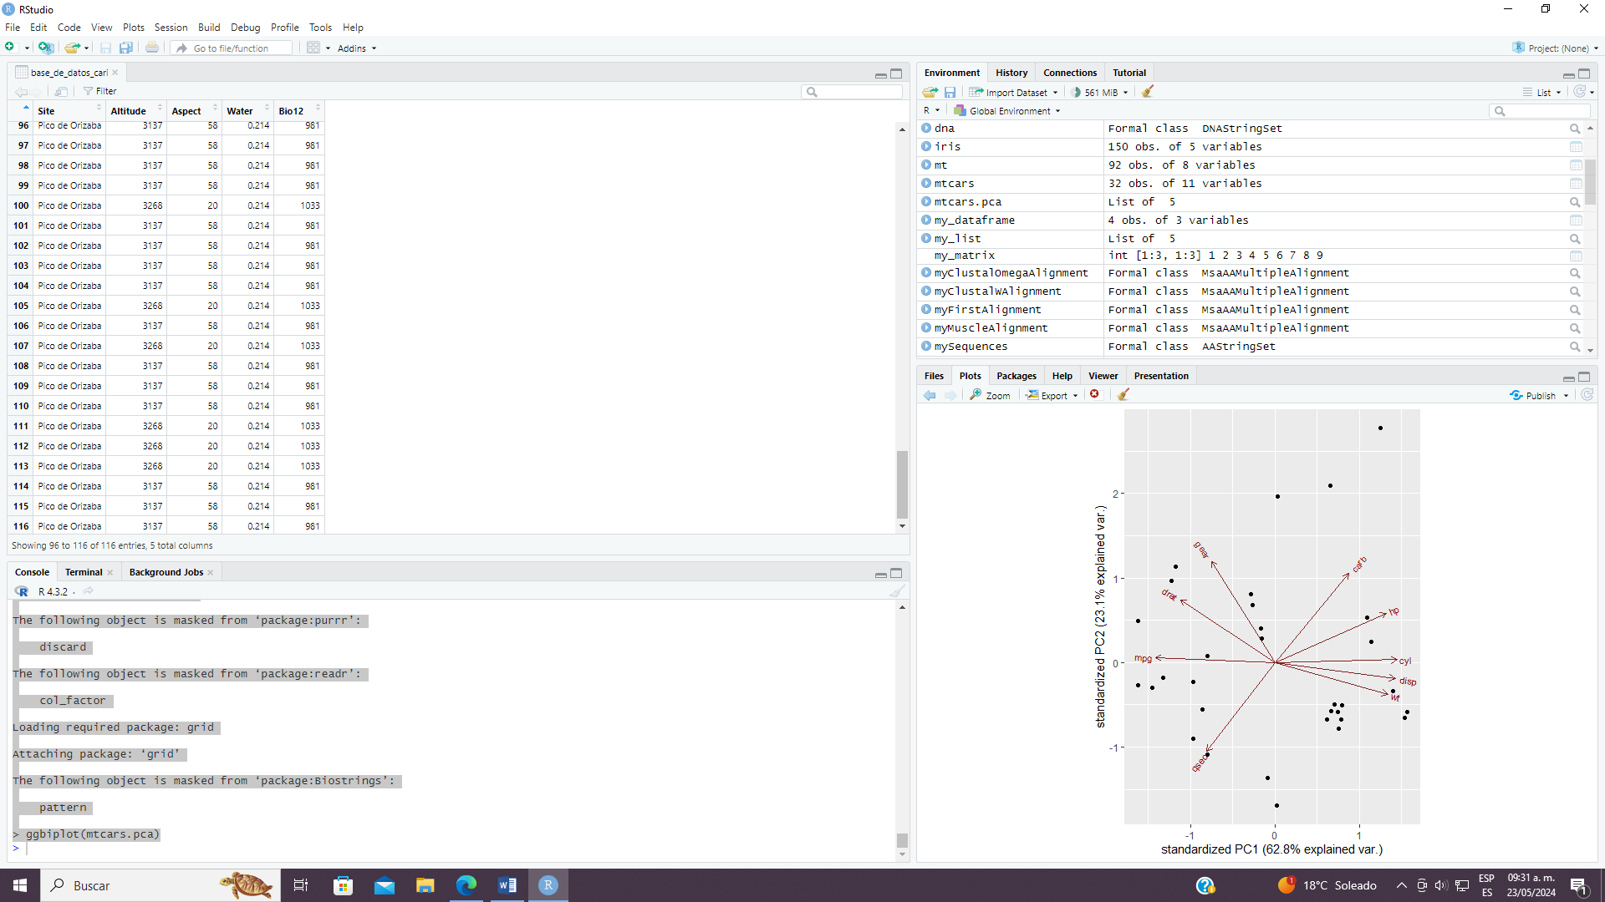

> ggbiplot(mtcars.pca, labels=rownames(mtcars), obs.scale = 1, var.scale = 1)

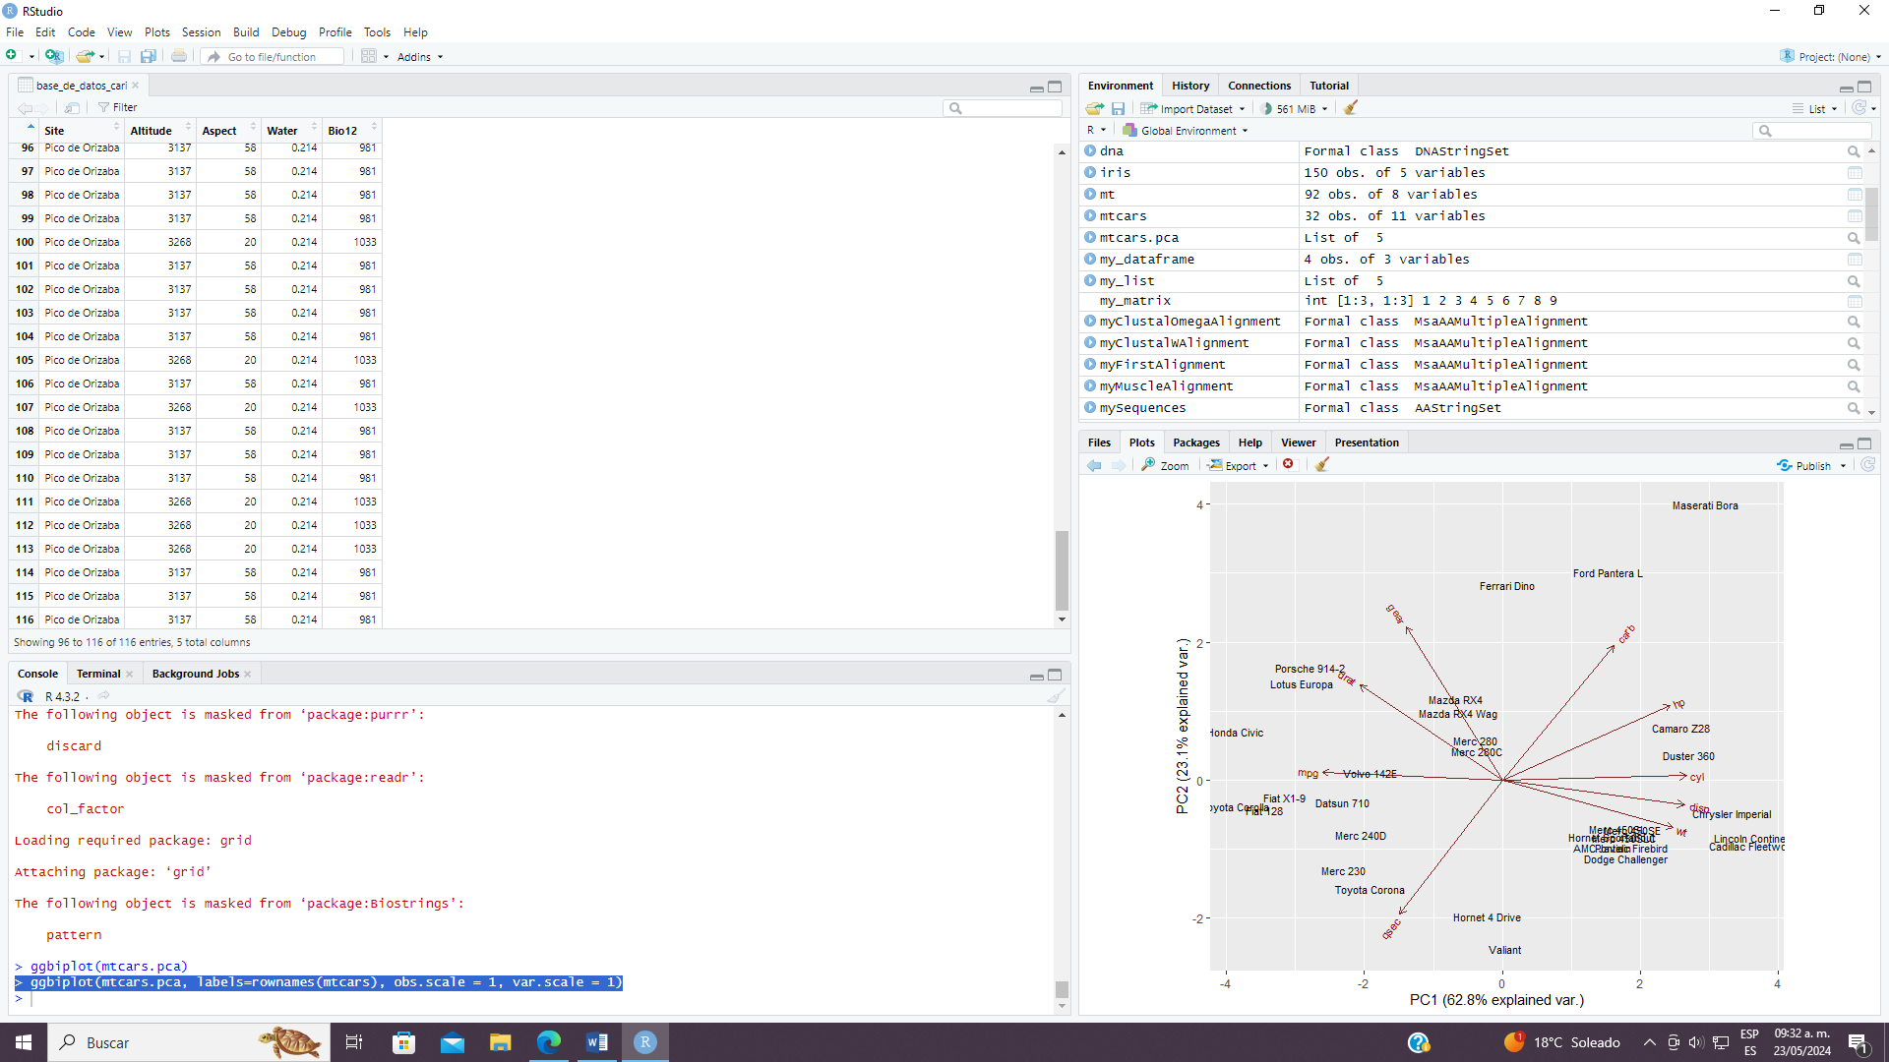

ggbiplot(mtcars.pca,ellipse=TRUE, labels=rownames(mtcars), groups=mtcars.country, obs.scale = 1, var.scale = 1)

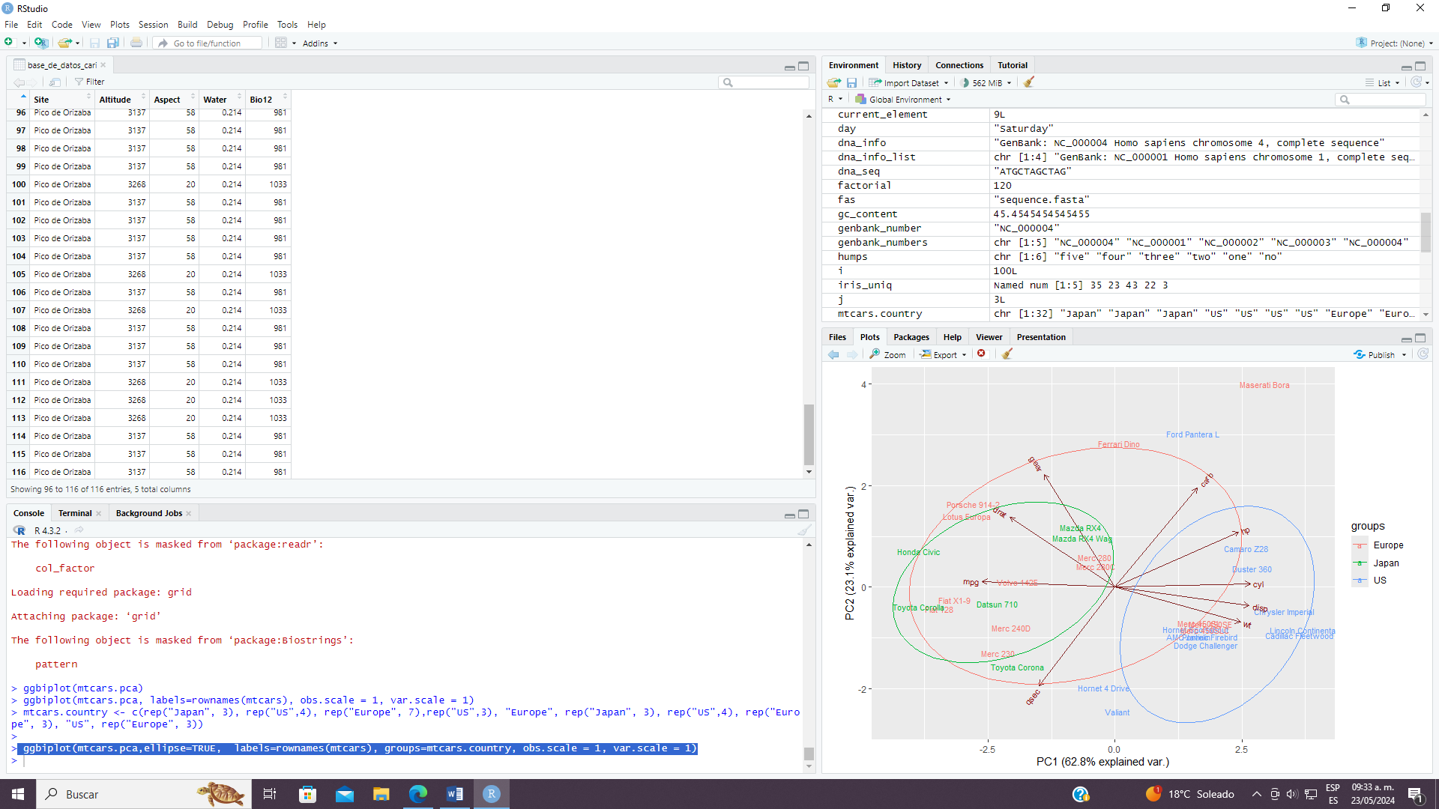

ggbiplot(mtcars.pca,ellipse=TRUE,choices=c(3,4), labels=rownames(mtcars), groups=mtcars.country)

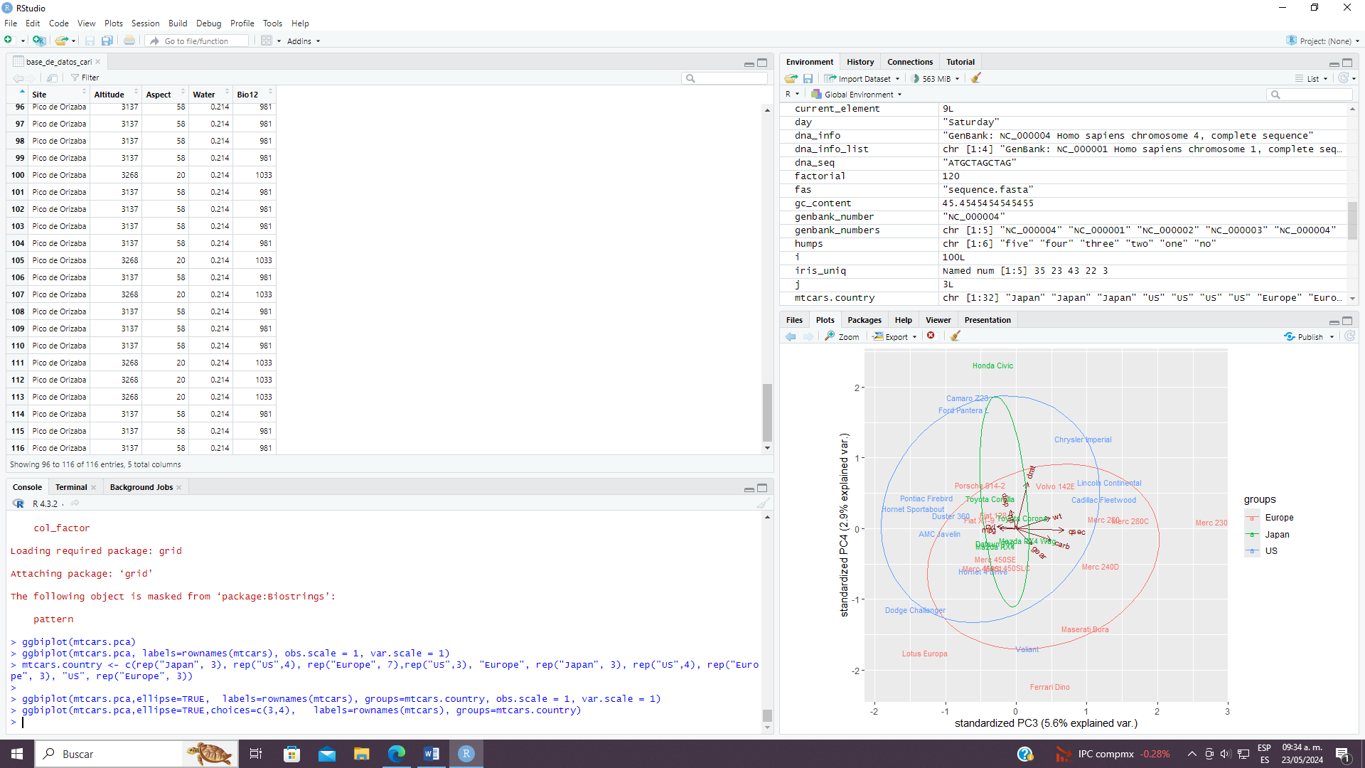

> #viewing the datset

> head(irisdf)

sepal_length sepal_width petal_length petal_width species

<num> <num> <num> <num> <char>

1: 5.1 3.5 1.4 0.2 Iris-setosa

2: 4.9 3.0 1.4 0.2 Iris-setosa

3: 4.7 3.2 1.3 0.2 Iris-setosa

4: 4.6 3.1 1.5 0.2 Iris-setosa

5: 5.0 3.6 1.4 0.2 Iris-setosa

6: 5.4 3.9 1.7 0.4 Iris-setosa

> df <- irisdf[,c(1:4)]

> head(df)

sepal_length sepal_width petal_length petal_width

<num> <num> <num> <num>

1: 5.1 3.5 1.4 0.2

2: 4.9 3.0 1.4 0.2

3: 4.7 3.2 1.3 0.2

4: 4.6 3.1 1.5 0.2

5: 5.0 3.6 1.4 0.2

6: 5.4 3.9 1.7 0.4

> df.pca <- prcomp(df[,c(1:4)], center = TRUE, scale. = TRUE)

> summary(df.pca)

Importance of components:

PC1 PC2 PC3 PC4

Standard deviation 1.7061 0.9598 0.38387 0.14355

Proportion of Variance 0.7277 0.2303 0.03684 0.00515

Cumulative Proportion 0.7277 0.9580 0.99485 1.00000

> str(df.pca)

List of 5

$ sdev : num [1:4] 1.706 0.96 0.384 0.144

$ rotation: num [1:4, 1:4] 0.522 -0.263 0.581 0.566 -0.372 ...

..- attr(*, "dimnames")=List of 2

.. ..$ : chr [1:4] "sepal_length" "sepal_width" "petal_length" "petal_width"

.. ..$ : chr [1:4] "PC1" "PC2" "PC3" "PC4"

$ center : Named num [1:4] 5.84 3.05 3.76 1.2

..- attr(*, "names")= chr [1:4] "sepal_length" "sepal_width" "petal_length" "petal_width"

$ scale : Named num [1:4] 0.828 0.434 1.764 0.763

..- attr(*, "names")= chr [1:4] "sepal_length" "sepal_width" "petal_length" "petal_width"

$ x : num [1:150, 1:4] -2.26 -2.08 -2.36 -2.3 -2.38 ...

..- attr(*, "dimnames")=List of 2

.. ..$ : NULL

.. ..$ : chr [1:4] "PC1" "PC2" "PC3" "PC4"

- attr(*, "class")= chr "prcomp"

> library(ggbiplot)

> ggbiplot(df.pca)

